**Online Resource Tracking System using Agile Project Management**

Submitted By

Riya

Priyasha

Manish

Pratiksha

Antra

Parag

Devesh

Under Supervision of

Mr. Santosh Kumar

Abstract

The aim of this project “Online Resource Tacking System using Agile Project Management” is to track the availability of resources for optimum usage. Also, it also helps to build a coherent flow of resources and data amongst the full department.

With the help of this project, whenever any team member will be in a need of resources, they can forward the resource request to their respective Project Manager. After the process of checking If the required resource is present in the resource pool or not, the request is sent to the Partner Company. The partner company sends a CV of the requested resources and with the valuable assistance of the project manager, the interview is held and the resources are finally dispatched. Throughout the process, resource tracking is the fundamental principle on which this project is working for optimum and efficient usage of any organisation’s resources.

Acknowledgement

It was a great experience working on the project “Online Resource Tracking System using Agile Project Management”.

We would like to express our sincere gratitude to the Project Guide Mr. Santosh Kumar for providing his valuable guidance, comments and suggestions throughout the course of the project. We would also like to thank the SCRUM Master Ms. Antra, Development Team members Ms. Pratiksha, Master Manish, Master Devesh and Master Parag and the Documentation Team Ms. Riya and Ms. Priyasha for their help and support.

Lastly, we are also thankful to TATA Steel Ltd. For providing us the opportunity to work under them.

Table of Contents

1. Objective of Project
2. Introduction of Agile
3. Why Agile?
4. Comparison of traditional method with Agile Method
5. SCRUM
6. Working Software
7. Testing
8. References

**Objective**

When a request for a product is made by a person or a company, they expect the best quality product in the given time frame in which they have asked.

The project “Online Resource Tracking System using Agile Project Management” provides insight on a new and improved method for producing the best resources to the product owner in a given time frame, where the product owner is also involved and the production team are encountered with less of a hassle when the final product is delivered.

**Introduction of Agile**

Agile Project Management (APM) is an iterative approach to planning and guiding project processes. The project is completed in small sections which are conducted in work sessions which run from design phase to testing and quality assurance (QA).

These small sections are called sprints, which is the term for iteration used in SCRUM. Furthermore, they are generally short, typically two to four weeks long.

* *Agile Manifesto*
* Individuals and interactions over processes and tools
* Working software over comprehensive documentation
* Collaboration with customers over negotiation of contract.
* Being responsive to change over following a plan.
* *12 Principles of Agile*
* Customer satisfaction through early and continuous delivery is highest priority.
* Welcoming changing requirements.
* Delivery of working software frequently during a preferred timescale.
* Collaboration between business workers and developers.
* Face-to-face conversations
* Provision of working software.
* Constant pace maintained between users, sponsors and developers.
* Technical excellence and good design.
* Art of maximizing work not completed is essential.
* Teamwork.
* Regular meeting of the team to reflect on their work and how to make it more effective.
* Projects around motivated people.

**Why Agile?**

There are numerous reasons as to why Agile method is used. Following are a few key reasons.

* Rapid deployment of solutions
* Greater collaboration with users
* Efficient resource utilisation
* Increased customer satisfaction
* *Working of Agile Project Management*

Rapid feedback, continuous adaptation and QA best practices into their iterations.

Usage of CD (continuous deployment) and CI (continuous integration) to speed up release and usage of products.

No project manager required, the role is distributed among the team. Many organizations still use them, but as the role of a coordinator with the product owner. They take responsibility for the projects completion.

APM calls teams for time and cost evaluation. There is usage of velocity, burndown and burnup charts.

**Comparison of Traditional Method (Waterfall) with Agile Method**

|  |  |
| --- | --- |
| Traditional Method (Waterfall) | Agile Method |
| Customer feedback taken when the implementation of task is completed. | Incremental and iterative approach and encourages changing requirements from product owner. |
| The cycle time is increased due to heavy amounts of documentation. | Frequent customer collaboration and delivery of working software. |
| Most suited to simple projects with static business requirements. | Time cycle is reduced due to the involvement of customer in the scrum team. |

**SCRUM**

SCRUM is a method for managing software delivery which provides a lightweight process framework which incorporates iterative practices. It helps organizations deliver working software to the product owner more frequently.

SCRUM works using sprints, which is the term used that breaks up the workload into small iterations and each sprint is delivered to the product owner as it is completed.

* *Framework*

The framework of SCRUM is a specific 3:5:3, where SCRUM Team has 3 roles, there are 5 Events and there are 3 Artifacts.

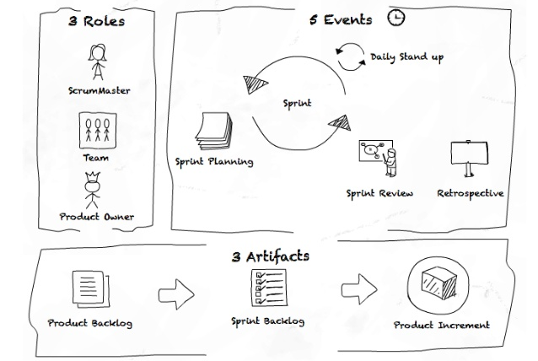

*Roles(3)*

There are three main roles in a SCRUM. They are:

* Product Owner
* SCRUM Master
* SCRUM Team

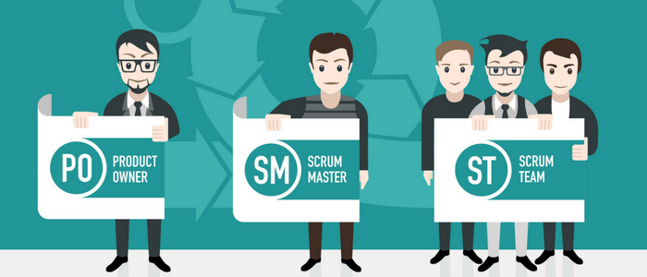

The Product Owner is the project’s key stakeholder and is the primary user of the product. They must be a part of the team and should be open to communication with the team and the other stakeholders.

The SCRUM Master is a servant-leader who ensures that the team continuously and diligently follow the practices of SCRUM. They conduct the meetings with the Product Owners and also hold the Daily SCRUM meetings. Furthermore, they don’t have authority over the team, but do have authority over the process.

The SCRUM Team have a minimum of 5 members and a maximum of 9 members who work together to complete the tasks which they have been assigned to in the sprint.

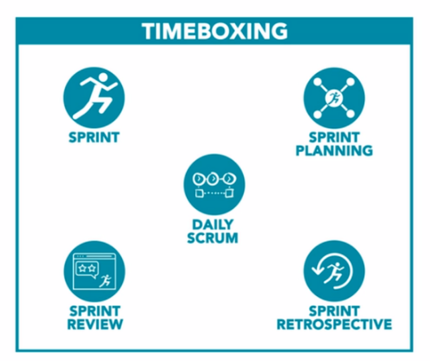*Working Events-Sprint(5)*

A sprint in SCRUM is the term used for dividing the workload into small iterations which upon completion, is delivered to the product owner for their feedback.

There are four main aspects in a sprint. They are

* **Planning**: It is the work to be performed in the Sprint and requires the collaboration of the entire SCRUM Team.
* **Daily SCRUM**: Daily SCRUM is a 15- minute, internal, time-boxed event for the development team to synchronize activities and create a plan for the next 24 hours. The Development team inspects the progress towards the Sprint Goal and also towards completing the Sprint Backlog.
* **Review**: The team has completed each product backlog item which was brought into the Sprint, but the main reason for the review is that the SCRUM Team displays what work they have completed during the sprint.
* **Retrospective**: The Sprint retrospective is an opportunity for the SCRUM Team to go through what work they have completed during the sprint and check for improvements to be done during the next Sprint. Four questions only are discussed. They are
  + - What went well during the Sprint?
    - What could be improved?
    - What has been completed yesterday?
    - What will be done today?

*Artifacts*

* **Product Backlog**

|  |  |  |  |  |  |
| --- | --- | --- | --- | --- | --- |
| ID | As a | I want to be able to | So that | Priority | Status |
| **1** | **Team Member** | **Add new request** | Appeal for request is put forward to the Project Manager | **Should** | **In Progress** |
| **2** | **Project Manager** | **See all the requests and their details and check if that resource is available in the resource pool** | **The project manager is informed about the availability of the resources before any further process.** | **Should** | **Done** |
| **3** | **Project Manager** | **Send a mail to the partners and change status of request** | **To inform them of a new request status.** | **Must** | Done |
| **4** | **Partner company** | **Change the status to CV sent** | **The project manager is informed about the details of the requested resources.** | **Should** | **Done** |
| **5** | **Project Manager** | **Set up the interview and update the resource tracker** | **The company partner and the team members have the required interaction as a tracker maintains the current status of resource pool.** | **Must** | **In Progress** |
| **6** | **Project Manager** | **Able to retrieve the requested resources from the resource pool if available and should be able to replace the used resources by following the above mentioned proceedings.** | **Team Members get the required resources sooner and optimum usage of resources is maintained.** | **Must** | **In Progress** |
| **7** | **Partner Company** | **Updates the sending of the CV** | **Status of the details of the requested resources are updated.** | **Should** | **Done** |
| **8** | **Administrator** | **Add new resources** |  | **Must** | **Done** |
| **9** | **SCRUM Master** | **Ensure that all of the work is coordinated** | **There is an efficient flow of functionality amongst the project team.** | **Should** | **In Progress** |

* **Sprint 1 Backlog**

|  |  |  |  |
| --- | --- | --- | --- |
| FORECAST | TO DO | IN PROGRESS | DONE |
| Email | Sending the email from the project manager to the partner company asking for the resources. |  |  |
| Drop-down for status update |  | Status for the availability of the resources |  |
| Design Flaw | To create seperate windows of access for the 3 different entities :   1. Project Manger 2. Team members 3. Partner Company. |  |  |

* **Sprint 2 Backlog**

|  |  |  |  |
| --- | --- | --- | --- |
| FORECAST | TO DO | IN PROGRESS | DONE |
| Resource Pool | Separate entry for the resource pool |  |  |
| Requests can be sent for the resource pool |  | The request send by the project manager to replace the number of used resources from the resource pool. |  |
| Updating Resources |  | The required attributes for the resources were updated. |  |
| Add request |  |  | Request for the resources by the project manager. |

* **Sprint 3 Backlog**

|  |  |  |  |
| --- | --- | --- | --- |
| FORECAST | TO DO | IN PROGRESS | DONE |
| Sending the CV |  |  | The Company partner sends the CV of the resources to the Project Manager for the interview to be initiated. |
| Summary of status | A detailed vision of all the requests to be a hired or rejected to get an idea of the status by creating a drop down menu for the re |  |  |

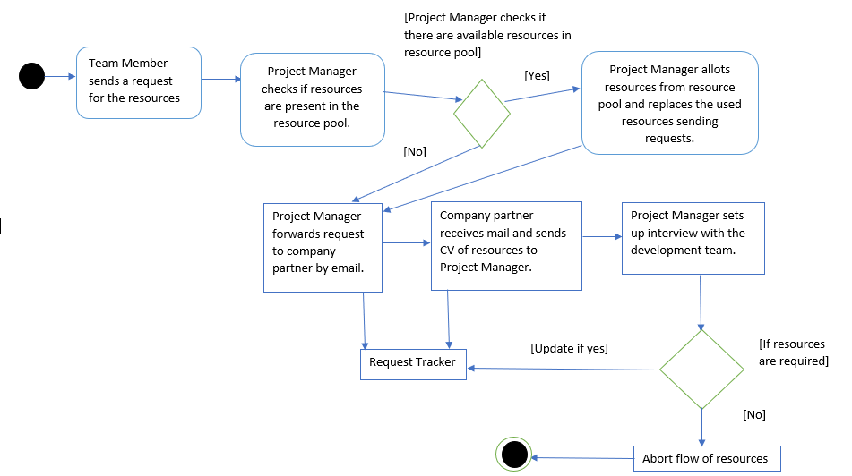*Activity Diagram*

*Definition of Done (DoD)*

* The Team Member can add new requests
* The Project Manager can see all the requests and their details. They can also check if the resource is available in the resource pool. They can send emails to partners and change request status and also they are able to set up the interview and update the resource tracker. Lastly, they can retrieve the requested resources from the resource pool if available and should be able to replace the used resources by following a set procedure.
* The Partner Company can change the CV status to CV sent.
* The Project Manager can add new resources

*Acceptance Criteria*

* Requests for resources are sent by Team Member.
* Resource pool is always up-to-date or is being updated frequently.
* Emails for requests are forwarded to Partner Company.
* CV’s are sent by the Partner Company to the Project Manager.
* Information regarding the interviews are correct.
* Request tracker is always up-to-date.

**Working Software**

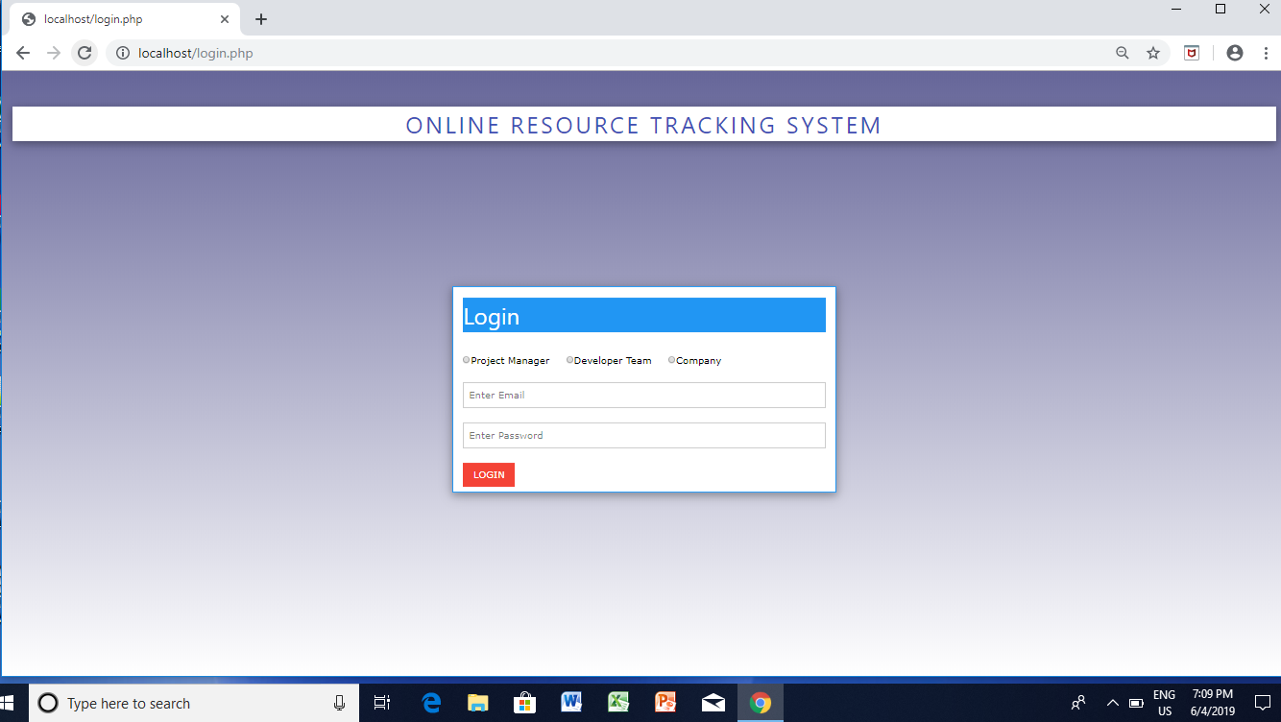

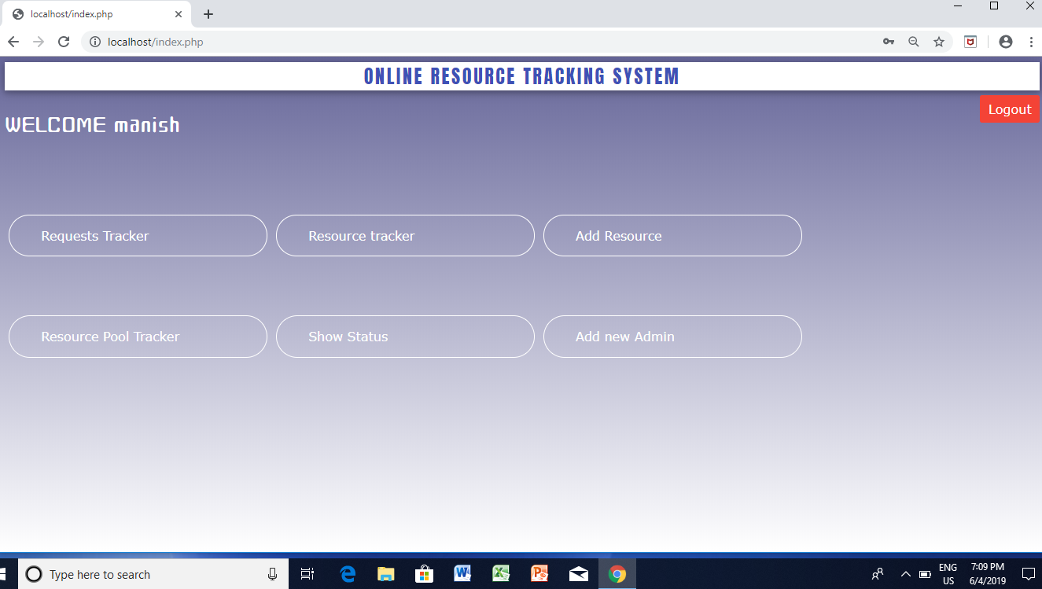

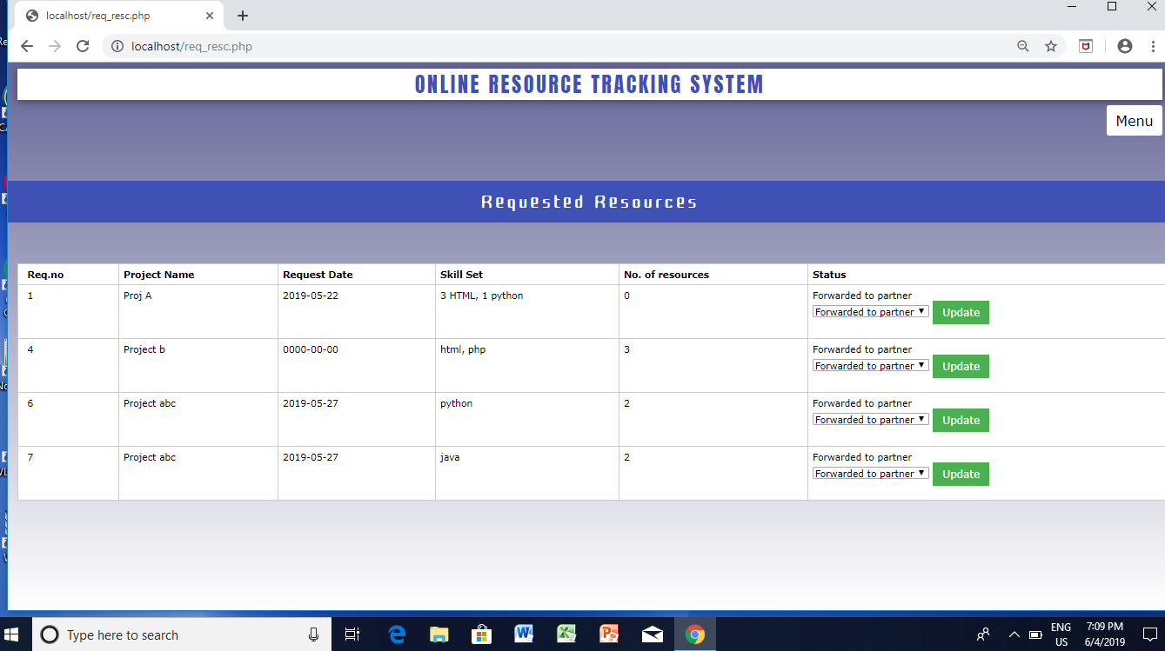

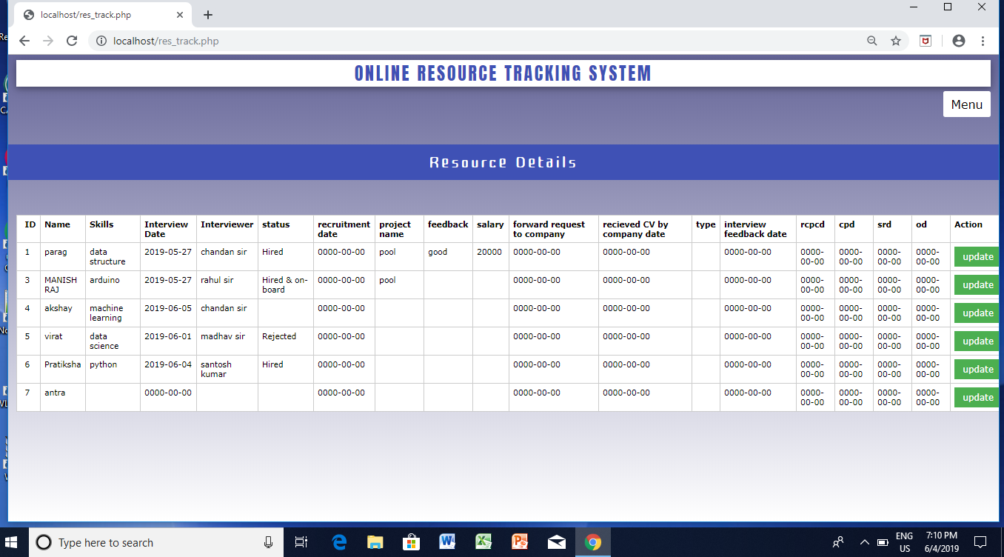

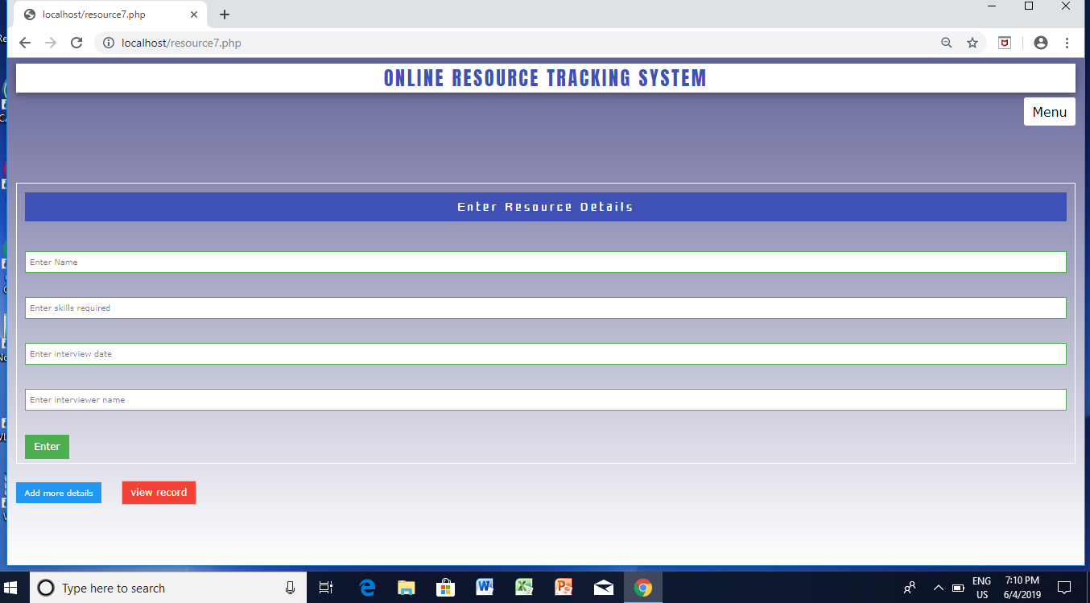

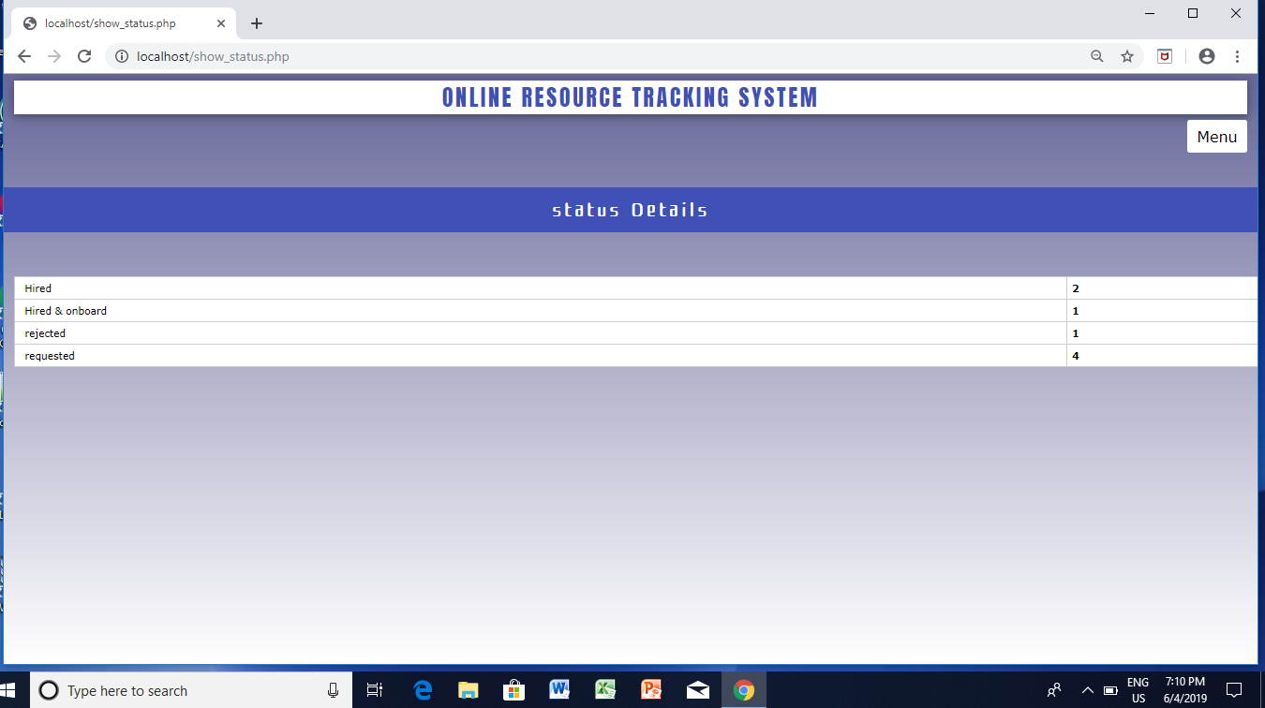

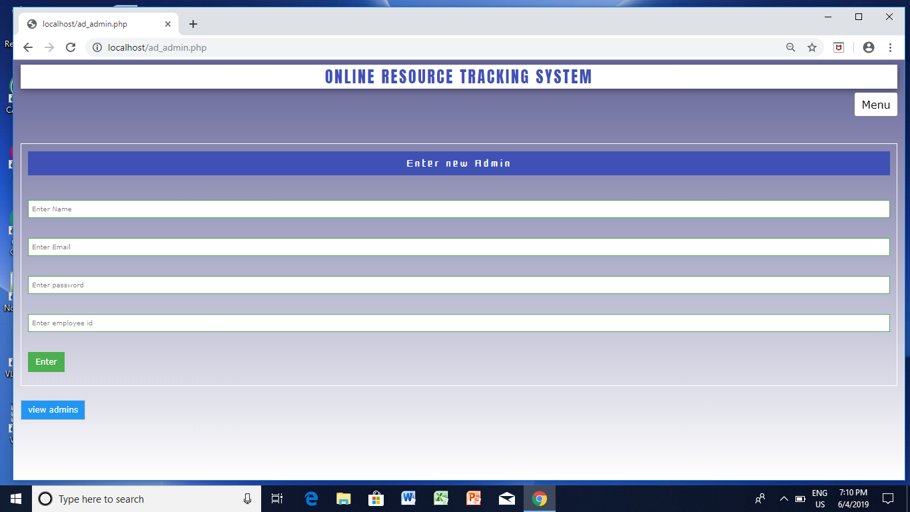

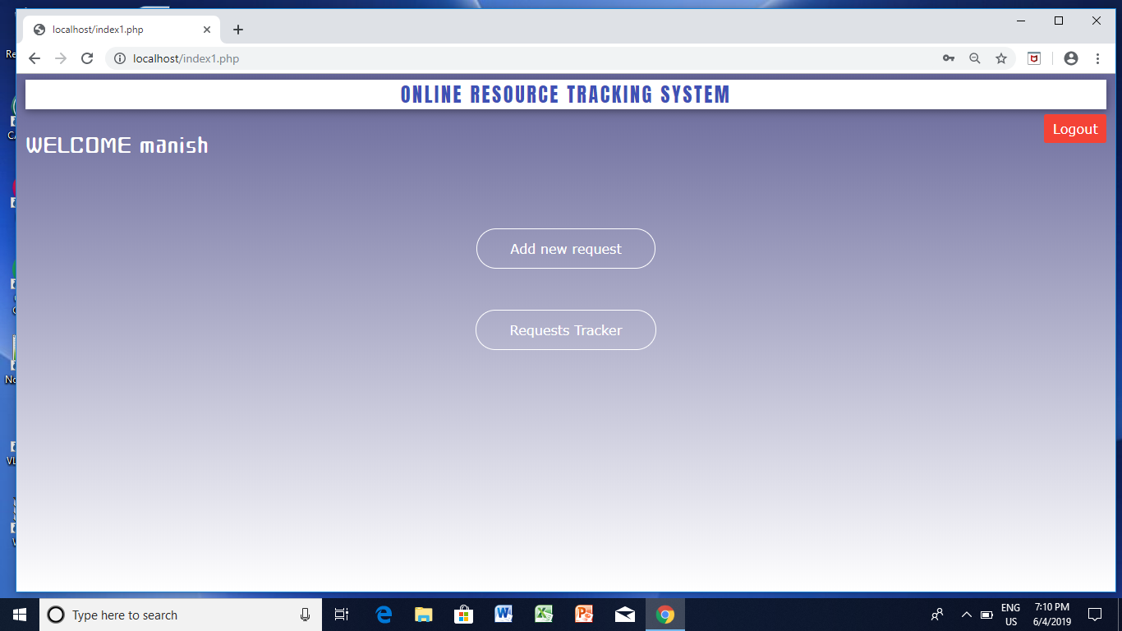

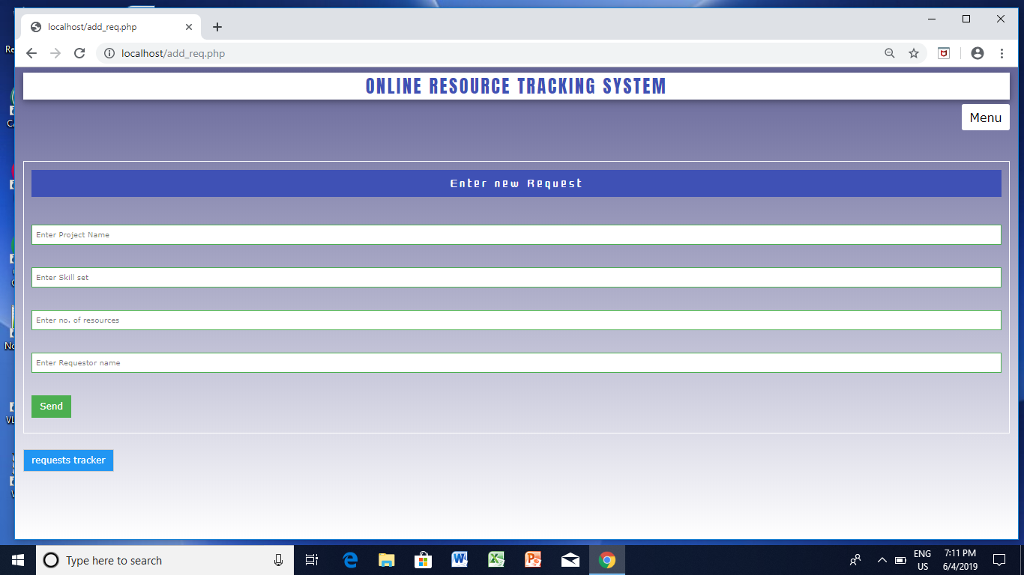

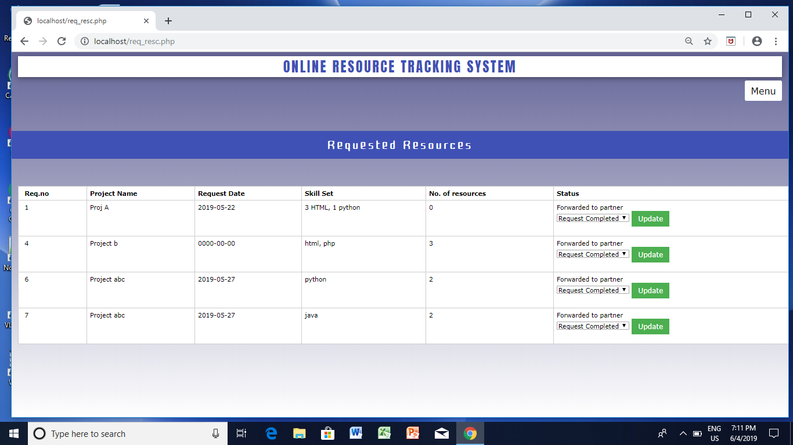

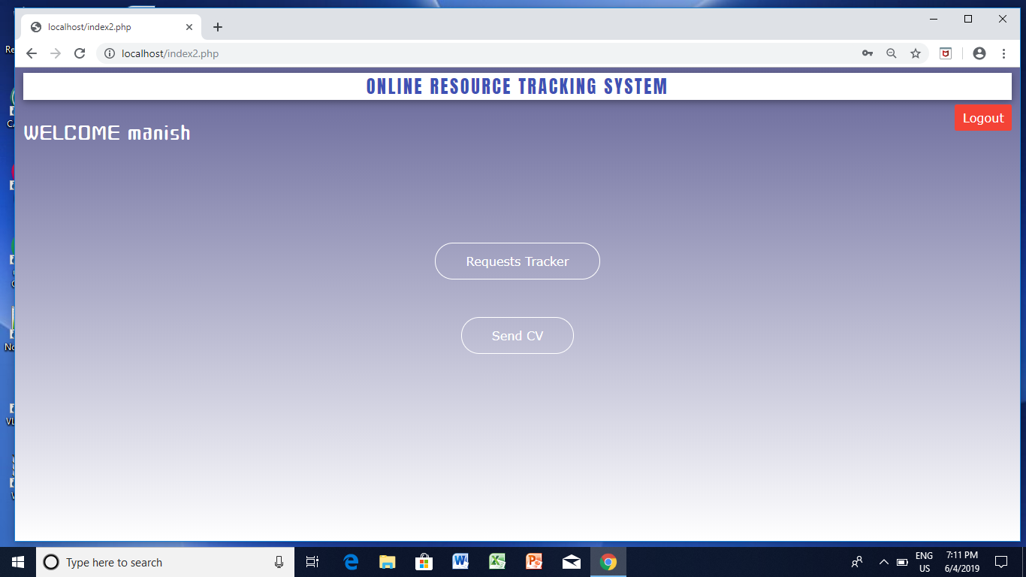

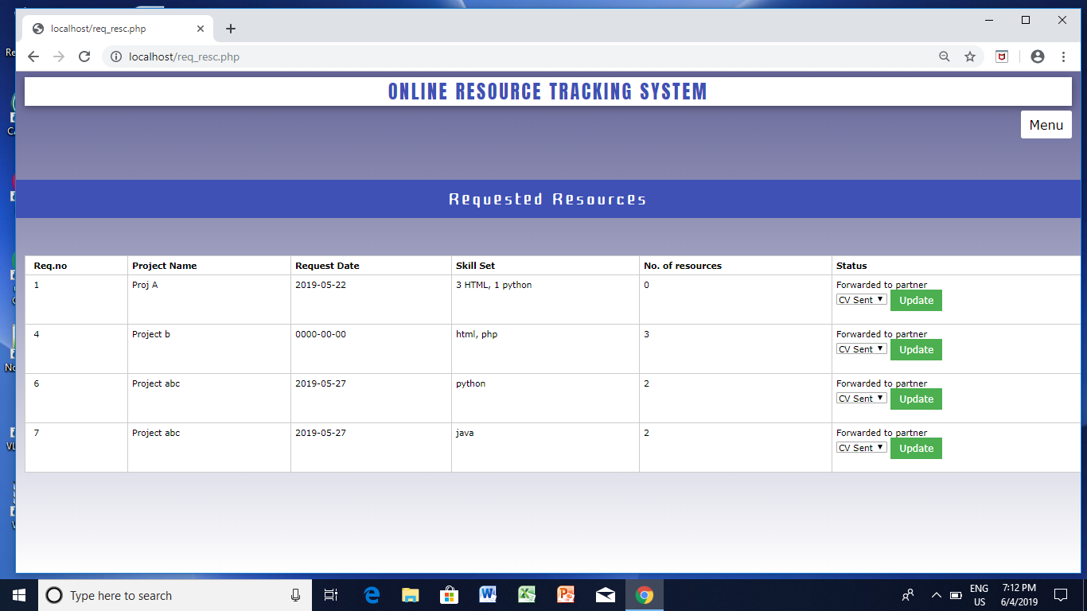

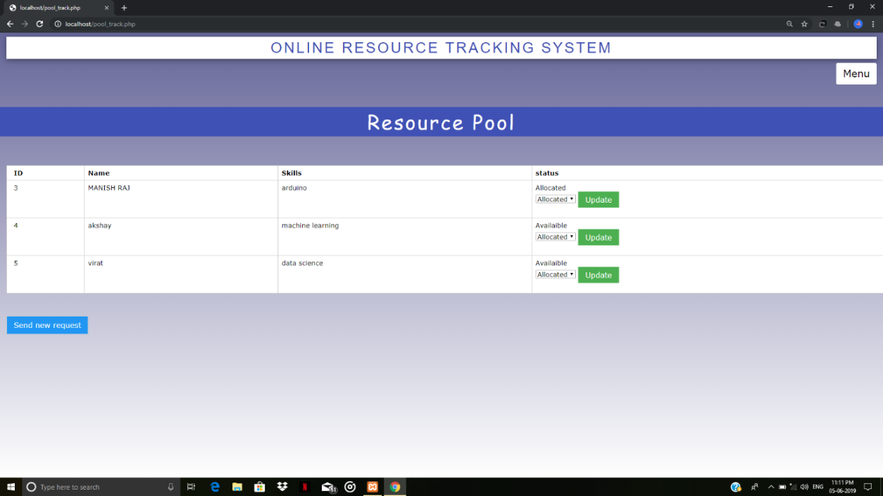

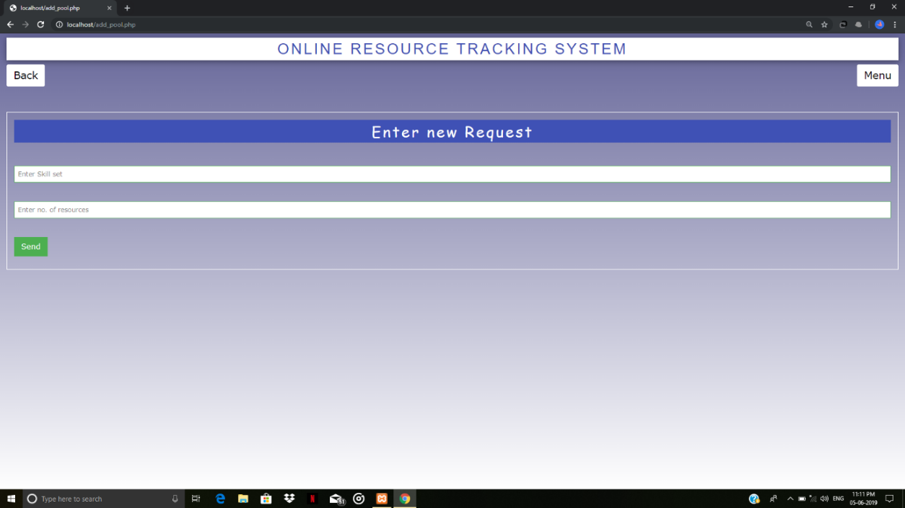

**Testing**

